Rusnak, Maciej

Multiscale modeling project

Cellular automata

# Design requirements:

* Class1: implementation of simple grain growth algorithm with 300x300px (cells) simulation window. Application must have 1 Neighborhood describes the closest neighbors of a particular cell. It can be in 1D, 2D and 3D space.), file export/import and GUI.
* Class 2: Inclusion: Types: – square (with diameter d <1:100>) – circular (with radius r <1:100>)
* Class 3: Control of grain boundary shape: – extension of Moore neighborhood (rule 1 – 4)
* Class 4: Different microstructure type: – substructure – dual phase (CA -> CA).
* Class 5: Grain boundaries selection (GB size, selection of grains).

# Final project specification:

Out of all requirements from previous paragraph, following were implemented (sometimes with changes required to make application faster or more stable);

* Simple grain growth algorithm was implemented on max 300x300 cells, due to poor algorithm optimization, simulation requires too much time for denser cells field,
* Import/export of simulation results and data was not implemented. I was not able to make application stable with this feature,
* GUI was implemented with full functionality offered by this application,
* Five neighborhoods were implemented: MOORE’a, Von Neumann’a, Hex Random, Penta Random, Further Moore
* Inclusion type was implemented, but diameter was limited to 20, again, due too poor algorithm optimization and long simulation times.
* Dual Phase microstructure was implemented,
* Grain boundary selection was implemented,

# User Interface:

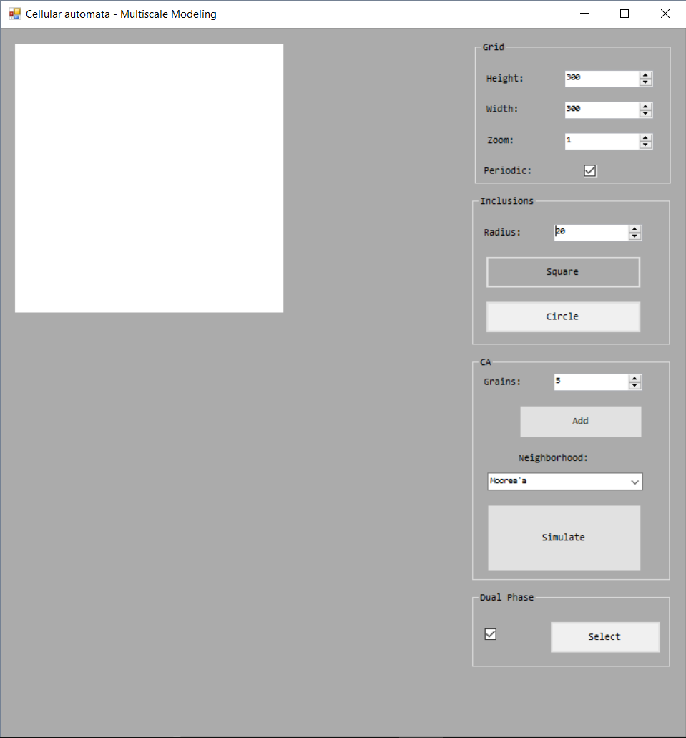

User interface options:

* Grid: allows to set cells grid size and enables user to zoom simulation results up to 4 times,
* Inclusions: allows user to set inclusion radius and type, inclusions are added to simulation by mouse click on working area (cell grid),
* CA: allows user to set grains count, neighbors type and set simulation in motion,
* Dual Phase: allows to select microstructures for next simulation,

# Example simulations:

## Moore’a 25 grains:

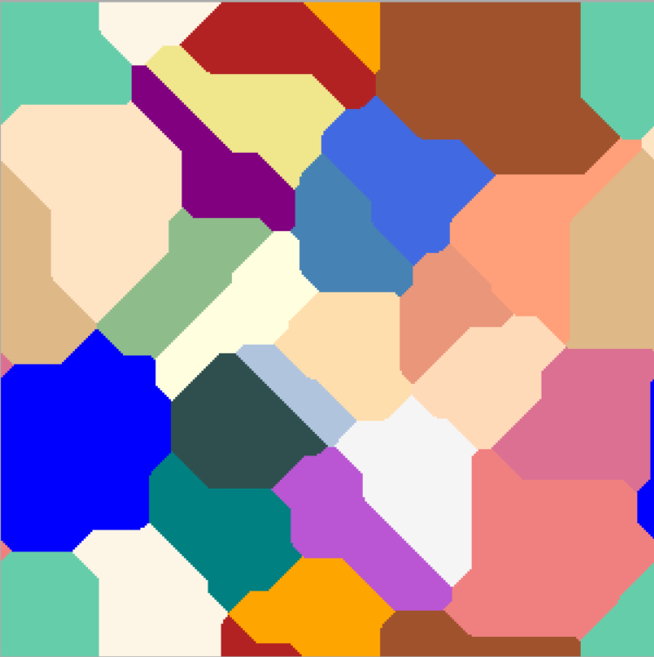

## Von Neuman 50 grains:

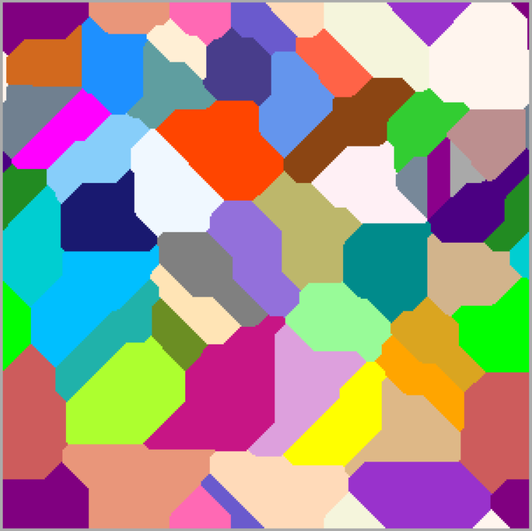

## Moore’a 100 grains with inclusions:

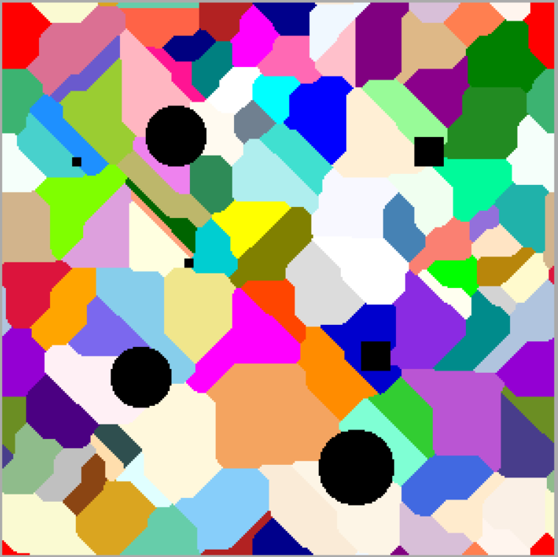

## Dual phase:

